**Java Importance of Udemy:**  
  
For developing java program, we required JDK.

-> So, we require this, it will have compiler and runtime environment which will write the java program and execute them.

-> When we install JDK along with JRE and JVM is available for us

So, we execute a java program we required a JRE,

JVM -> is part of JRE -> is part of JDK.  
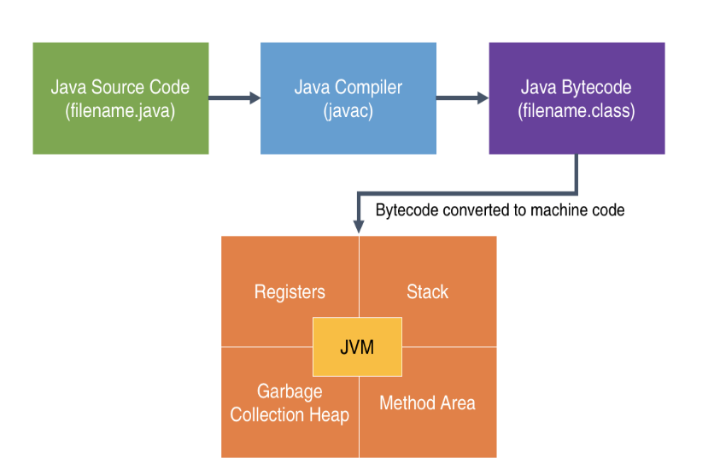 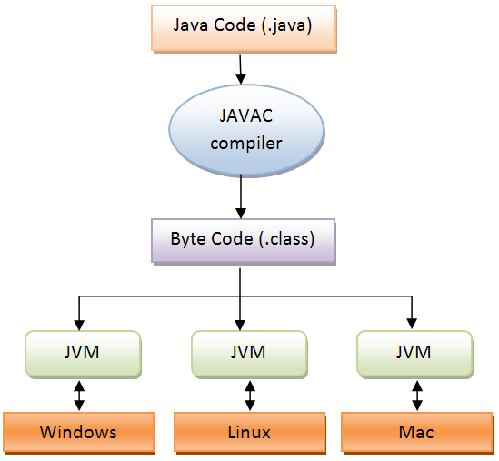

what is JRE -> JRE will contain library of java classes.

what is JVM -> For executing Java program we required JVM as a part of JRE, without JVM, JRE is cannot execute, Java program that will running inside JRE, that actually executed by JVM.

Look at the flow diagram:

EX: First.java -> Java c -> First. Class

Java c – Java c is a compiler that is the part of JDK.  
First. Class – This executes by java program; this will do by JRE and internally it uses JVM.

**Understand the skeleton of the java program:**  
File name is MyFirst.java  
 import java.lang.*;

Public class MyFirst {

public static void main(String args[]) {

System.out.println(x);

System.out.println(y);

}

}

import java.lang.*; - lang is a language package, it is a not mandatory of this package, even we not importing this package automatically it gets imported in our programs, because we using a System class.  
MyFirst – Class name should be same as the file name.

How to run this code on CMD -> use javac MyFirst.java -> Generate byte code MyFirst.class(This is compiled file) then -> java MyFirst -> execute our output.

Main method – public static void main(String args[]){  
 }  
void -> main method should be void always it should not giving any return value  
Why access specifier as:  
public – Because when the JVM is execute the program, call the main method so this main method is inside the class JVM should be able to see the main method, this reason we make it as always public.  
Why the static?  
static – If it is a static then we can directly call without creating a object of a class just by using class name.  
Command line arguments:  
String args[] – This we can called as commend line arguments, This is optional, But the java   
program we must write.   
println – Actually println is a method printing anything on the screen.

out – is an object, as a said in java nothing is outside of classes and object, so this inside some object called as out and that is inside a class System.

For the main method:  
public static void main() -> written like this JDK will compile the program, but JVM will not compile. When JVM do compile we written like this only public static void main(String args[])

import java.lang.*;

class First { In CMD I check this output:

static int x = 10; javac First.java

static int y = 20; java First varun kumar k m

public static void main(String[] args) { output is:

System.out.println(x); 10

System.out.println(y); 20

System.out.println(args[0]); varun

System.out.println(args[1]); kumar

System.out.println(args[2]); k

}

}  
  
**How to read the data from the keyboard in java:**-> Java provides a Scanner class that will use to read the data from the different sources.  
 Here learn how to read the data from keyboard.  
Scanner class is present in util package, There are some build in packages in java one of is util, this class was provided by java version 5 onwards.

We are using a Scanner class, first we are creating an object.   
 Scanner s = new Scanner(System.in);   
Scanner – This is the class  
Scanner – This is the constructor  
System.in – This object is associated with keyboard. -> This object is given to constructor   
 Scanner and storing into a reference variable.  
 This is a reference for the keyboard.

Scanner class having some methods are:  
1) nextInt() – Will read an integer  
2) nextFloat() – will read an float value   
3) nextDouble() – will read an double value   
4) next() – If we want to read a String name or any word, we use this method, read single word   
5) nextLine() – If we want to read a sentence like a line use this method, read multiple words.   
6) nextByte() – it will read the byte value  
7) nextShort() – it will read the short value  
8) nextLong() – read the long value  
9) nextBoolean() – read the Boolean value  
There are other methods are also available are:  
10)hasNextInt() – Before reading an integer, I want to confirm next value is integer or not we  
 use this method. So, it returns Boolean value.   
11)hasNextFloat() - Before reading an float value, I want to confirm next value is float or   
 not we use this method. So, it returns Boolean value.

Important: I’m using scanner class; I would know which methods are there in scanner class.  
In CMD using this command we are getting an all methods. Using command javap java.util.Scanner  
javap – is a utility from java  
java.util – Thius is the package name  
Scanner – This is a class name  
Using this command it will show all the methods.

**Data types variable literals of Java:**   
  
Data is a important part of a program, all process we doing upon data, program is running on the memory, program should hold the data temporarily in the memory not an permanently in the hard disk memory, during the execution of the program, program should hold the data.  
So, where do we store the data? We store the data using variables so variable is meant for storing the data.  
Variable will have some data type, means that type of the data is storing that, some pre-defined types of the data available in java are:

Primitive data types: It means the basic data types in java that is build in compiler of java  
1) Integer – It means only integer value without any decimal value   
 * byte   
 * short  
 * int  
 * long  
2) Floating point – They can have numeric value and with decimal point  
 * float   
 * double  
3) Character – This is just storing for a character  
4) Boolean – This is just storing for a true or false.

In java every data type there is a built in class is available using this command in CMD:  
Integer – javap java.lang.Integer  
Float - javap java.lang.Float  
 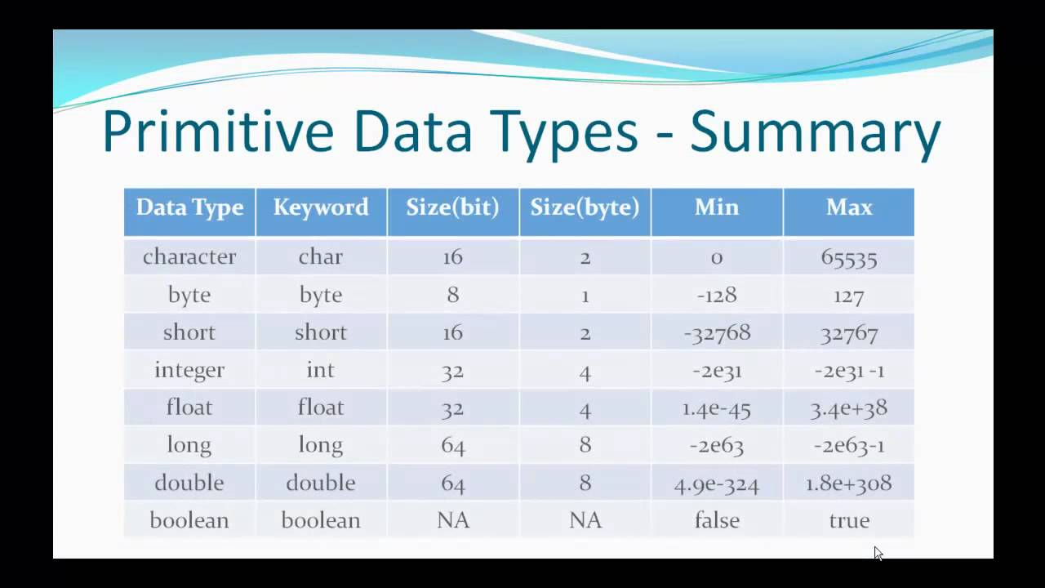

**What are variables?**  
A variable are used to storing the data, variable must have some data type.  
Variables - Naming rules  
1) Case sensitive  
2) Contains alphabets, Numbers, _or$  
3) Starts with alphabets, _or$  
4) Should not be a keyword  
5) Should not be a class name, If class is also use   
6) No limit on length of name  
7) Follow camel cases

**Literals:**Literals are all constant value that are used in our program, literals are also called as data type.  
EX: 1) z = 5*x+7*y -> This is for integer literals.  
 2) int value = 25 -> This is for integer literals.  
 3) double price = 153.78 -> This is for double literals.  
 4) area = 3.1425*radius*radius; -> double literals  
 5) char c = ‘A’ -> This is for character literals  
 6) String s = “java” -> This is for the String literals.  
Integer literals number can be represented a various number systems like:   
1) Decimal – This will have a 0,1,2,3,4,5,6,7,8,9   
2) Binary – This will have a 0,1

3) Octal – This will have a 0,1,2,3,4,5,6,7  
4) Hexadecimal – This will have a 0,1,2,3,4,5,6,7,8,9,A,B,C,D,E,F  
Our daily basis we are using a decimal value only.  
  
Byte, short, int = int literal Ex: byte b = 5; short s = 10; int I = 12;  
long is L or l literals Ex: long l = 10L; or long l = 10l;

Float is F or f literals Ex: float f = 10.2F; or float f = 10.2f;  
Double is D or d literals Ex: double d = 10.2D; or double d = 10.2d;  
char is ‘’ like this literals EX: char c = ‘a’;  
Boolean is true/false literals.

Floating point number: This number is don’t really store in the decimal in memory but the represent decimal number.  
Ex: 163.52*100/100 = 16352.*1/100 = 16352.*10^-2 -> This how the represents the decimal number  
16352. –> This portion is called as mantises, 10^-2 -> This portion is called as exponent.  
Finally we representing as 16352E-2

Double number: For this up to 6-7 decimal value is suitable as float, if more than 6 decimal value we consider as the double it suitable up to 14-15.

Character: Basically, computer doesn’t support alphabets, then we use numeric value instead of these characters, for those numeric codes English alphabets we called as ASCII Code.  
So, these Ascii codes are uppercase, lowercase alphabets and the digits, other special characteries anything in the keyboard all is available for ascii code.

Code defines for all natural languages like: English, kannada, hindi etc. So, those code are called as Unicode.  
Actually this ascii code is the part of Unicode. We need to find out our natural language code we use unicode.org.

EX: Ascii value are  
A, B, C, ------Z a, b, c, -------z 0, 1, 2, -----9 range is 0-127  
65 66 67 90 97 98 99 122 48 49 50 57 7 bits is sufficient

We talk about various supporting various natural languages 7 bits are not sufficient we need more spaces; this reason java takes 2 bytes for the character to support Unicode.

Boolean: This Boolean data type allows only true or false. For showing true or false 1 bit is sufficient 0 -> we can say positive and 1 -> we can say negative.

NetBeans -> NetBeans is an IDE (Integrated development environment) for writing programs mainly java programs, even though it supports other programming language also primarily it is used for java program netbeans.org.